

Republic of the Philippines

# Department of Education

REGION VIII- EASTERN VISAYAS SCHOOLS DIVISION OF CALBAYOG CITY

CALBAYOG CITY NATIONAL HIGH SCHOOL CALBAYOG CITY, SAMAR

# GENERAL PHYSICS 2 SECOND SUMMATIVE EXAMINATION

THIRD QUARTER

Test I. Direction: Choose the BEST answer on each question and write it on a separate sheet. You may show your solution for the problem-solving questions.

1. It is a physical property of an object that causes it to be attracted toward or repelled from another charged object; each charged object generates and is influenced by a force called an electromagnetic force.
   1. Nucleus
   2. Electric charge
   3. Electric potential
   4. Current
2. To start a car engine, the car battery moves 3.75 × 1021 electrons through the starter motor. How many coulombs of charge were moved?

a. −600 𝐶

b. −400 𝐶

c. −500 𝐶

d. −100 𝐶

1. Which of the following does not describe a capacitor as an electrical device?
   1. It stores charge and electrical potential energy.
   2. It is manufactured in many sizes and shapes.
   3. It is used to smooth out unwanted fluctuations due to power surges in electronic circuits.
   4. It allows current to pass through in any condition.
2. Two capacitors X and Y of capacitances 2 F and 4 F respectively are connected in series with a 12V battery. Which of the following statements is CORRECT?
   1. The effective capacitance is 6 F.
   2. The potential difference across the capacitor X is 8 V.
   3. Capacitors have the same charge of 36 C.
   4. The potential difference across the capacitor Y is 12 V.
3. Three capacitors 1.0𝜇𝐹, 1.5𝜇𝐹 and 2.0𝜇𝐹 are connected in series. What is the equivalent capacitance of the capacitors?

a. 4.0𝜇𝐹

b. 0.46𝜇𝐹

c. 2.17𝜇𝐹

d. 0.25𝜇𝐹

1. What is the potential difference across a capacitor on a 5𝜇𝐹 when the charge of capacitor is 120𝜇𝐶?
   1. 21 V
   2. 22 V
   3. 23 V
   4. 24 V
2. Two capacitors 1.0𝜇𝐹 and 0.5𝜇𝐹 are connected in series to a 100𝑉 current supply. What is the amount of charge stored in the 1.0𝜇𝐹?

a. 150𝜇𝐶

b. 33𝜇𝐶

c. 100𝜇𝐶

d. 50𝜇𝐶

1. Which of the following statements described a charge on capacitors P, Q and R as shown in Figure 17.1?
   1. 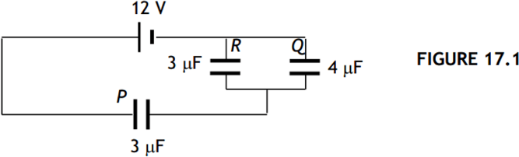The charge in R is more than the charge in P and Q.
   2. The charge in Q is more than the charge in P and R.
   3. The charge in P is more than the charge in Q and R.
   4. The total charge in Q and R is more than the charge in P.
2. What is the equivalent capacitance of the combination in Figure 17.5 if 𝐶 = 2𝜇𝐹.

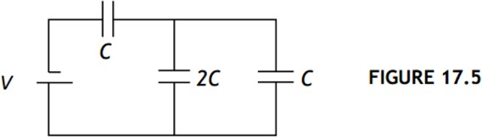a. 8.0𝜇𝐹

b. 3.3𝜇𝐹

c. 1.5𝜇𝐹

d. 0.8𝜇𝐹

1. A 9.0-V battery moves 20 𝑚𝐶 of charge through a circuit

running from its terminal to its negative terminal. How much energy was delivered to the circuit? a. 2.2𝑚𝐽

b. 0.18𝐽

c. 0.020𝐽

d. 4.5 × 103𝐽

1. Increasing the separation of the two charge plates of a capacitor, which are disconnected from a battery, will produce what effect on the capacitor?
   1. Increase charge
   2. Increase capacitance
   3. Decrease charge
   4. Decrease capacitance
2. A parallel plate capacitor has dimensions 4.0𝑐𝑚 × 5.0𝑐𝑚. The plates are separated by a 1.0 𝑚𝑚

thickness of paper (dielectric constant 𝑘 = 3.7). What is the charge that can be stored on this capacitor,

when connected to a 1.5 𝑉 battery? (𝜀0

= 8.85 × 10−12 𝐶2 )

𝑁𝑚2

a. 20 × 10−12 𝐶

b. 4.8 × 10−12 𝐶

c. 20 × 10−11 𝐶

d. 9. .8 × 10−11 𝐶

1. Inserting dielectric material between two charged parallel conducting plates, originally separated by air and disconnected from a battery, will produce what effect on the capacitor?
   1. Increase charge
   2. Increase voltage
   3. Increase capacitance
   4. Decrease capacitance
2. If the voltage is increased and the resistance stays the same, current will .
   1. Increase
   2. Stay the same
   3. Decrease
   4. Not enough info
3. If the voltage stays the same and resistance is increased, current will .
   1. Increase
   2. Stay the same
   3. Decrease
   4. Not enough info
4. In a series circuit, which of the following is the same throughout the circuit?
   1. Resistance
   2. Current
   3. Voltage
   4. Power
5. What voltage is needed to produce 2A of current through a 10Ω resistor?
   1. 20 V
   2. 5 V
   3. 0.2 V
   4. 2 V
6. Battery cells are connected in series to .
   1. Increase voltage output
   2. Increase current capacity
   3. Decrease voltage output
   4. Decrease current capacity
7. A current of 0.5 A flows in a circuit. Calculate the charge flowing through the circuit in one minute.
   1. 0.5 C
   2. 120 C
   3. 30 C
   4. 15 C
8. Which of the following will increase the resistance of a wire?
   1. Using a thicker/wider wire
   2. Increasing the temperature of the wire
   3. Using a shorter wire
   4. Using silver instead of copper
9. Which of the following factors would decrease the resistance through an electrical conductor?
   1. Decreasing the cross-sectional area of the cord
   2. Increasing the resistivity
   3. Increasing the cross-sectional area of the cord
   4. Increasing the length of the cord
10. What is the current in a circuit with a 2Ω resistor followed by a 3Ω resistor that are both in parallel with a

5Ω resistor? The voltage supplied to the circuit is 5 V.

* 1. 5 A
  2. 2 A
  3. 1.5 A
  4. 1 A

1. By how much will resistivity change if resistance and length are constant, and cross-sectional area is doubled?
   1. The resistivity will be quadrupled
   2. The resistivity will be halved
   3. The resistivity will not change
   4. The resistivity will double
2. Type of material for which ohm’s law is not valid
   1. Ampere
   2. Ohm
   3. Nonohmic
   4. Ohmic
3. Jhana was preparing to go on a hike in the woods. She gathered the equipment she would need and placed it on the kitchen counter. By chance, she placed her compass near an electric outlet. Although the compass was not moving, the compass needle turned because .
   1. The electric in the outlet produced a magnetic field
   2. The compass could only be used outdoors
   3. The kitchen counter was made of a magnetic substance
   4. The kitchen had a microwave over.
4. In a closed circuit containing one resistor and a battery, if the voltage in the battery increases, the current going through the resistor increases. Why does this occur?
   1. As the electrons are sped up, they bunch closer together.
   2. As the electrons are pushed more by the battery, they move faster through the circuit.
   3. As the electrons have more energy, they vibrate more rapidly.
   4. As the distance around the circuit increases, the electrons take longer to travel around.
5. 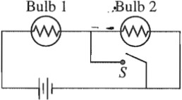The circuit in the figure (to the right) contains two identical bulb lightbulbs in series with a battery. At first bulbs glow with equal brightness. When switch S is closed, which of the

following occurs to the bulbs?

* 1. Bulb 1: Goes out, Bulb 2: Get brighter
  2. Bulb 1: Gets brighter, Bulb 2: Gets slightly dimmer
  3. Bulb 1: Gets brighter, Bulb 2: Goes out
  4. Bulb 1: Gets slightly dimmer, Bulb 2: Gets brighter

1. Three resistors are connected to an ideal battery, as shown in the figure below. The battery has an emf 𝜀.

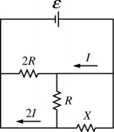Two of the resistors have known resistances 𝑅 and 2𝑅. The third resistor has unknown resistance 𝑋. The current in two of the branches is shown. What is the value of the unknown resistance 𝑋?

* 1. R/5
  2. R/2
  3. 2R
  4. R

1. Device used to measure potential difference
   1. Ammeter
   2. Barometer
   3. Odometer
   4. Voltmeter
2. Which of the graph obey the ohm’s law?

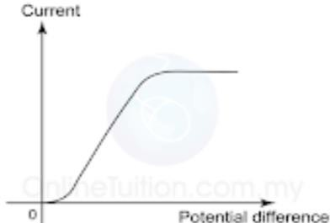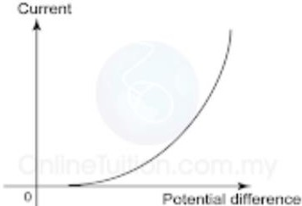a.

c.

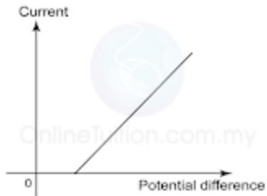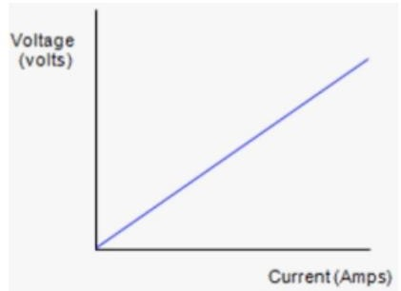b.

d.

1. Which device must be connected in parallel?
   1. Voltmeter
   2. Ammeter
   3. Ohmmeter
   4. Barometer
2. It is an energy supply by a battery/electrical source to a coulomb unit of charge.
   1. Potential difference
   2. Electromotive force
   3. Internal resistance
   4. Current
3. It is a work done or energy supplied to move a unit of charge from 1 point to another point in a closed circuit. This refers to .
   1. Internal resistance
   2. Electromotive force
   3. Potential difference
   4. Resistance
4. Instrument which transfers energy to electric charge in a circuit is .
   1. Battery
   2. Ammeter
   3. Voltmeter
   4. Galvanometer
5. If the direction of current is from positive to negative, the its is called .
   1. Electronic current
   2. Positronic current
   3. Conventional current
   4. protonic current
6. 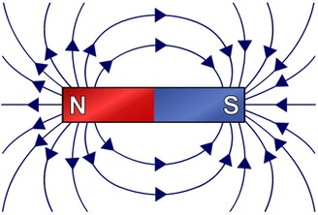Are the magnetic field lines in the picture, correct?
   1. Yes, because they point from north to south
   2. Yes, because the north pole is on the left in all pictures.
   3. No, because they point from north to south (they’re supposed to go the

other way)

* 1. No, because the North pole is not the left in all pictures (it’s supposed

to be on the right)

1. Which of the following actions would double the magnitude of the magnetic force per unit length between two parallel current-carrying wires? Choose all correct answers.
   1. Double one of the currents.
   2. Double both currents
   3. Double the distance between them
   4. None of the above
2. Magnetic flux density = 0.45 T, current = 1.37 A, length = 1.9 m, force on a conductor carrying a current

= ?

a. 0.0851

b. 0.317

c. 1.17

d. 0.106

1. Force on a conductor carrying a current = 5.37 N, magnetic flux density = 3.91 T, current = 4.33 A, length = ?

a. 0.0851

b. 0.317

c. 1.17

d. 0.106

1. The SI unit of magnetic field is .
   1. Weber, Wb
   2. Tesla, T
   3. Gauss, G
   4. Farad, F

Test II. Direction: Solve the following problems and show your COMPLETE SOLUTION.

* + 1. Solve for the total current and voltage drop of each resistor in the given circuit below. *(5 points)*

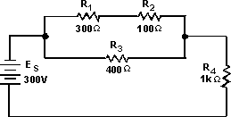

* + 1. Find the current through each of the battery. *(5 points)*

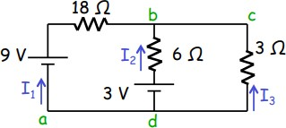

Certified True and Correct:

LAZARO R. BINAY JR. SST-II

Noted:

MARISH LOU G. FERNANDEZ

SST-III/STEM Department Head